Exercise 13
1. Which command displays the MySQL version?
SELECT VERSION();
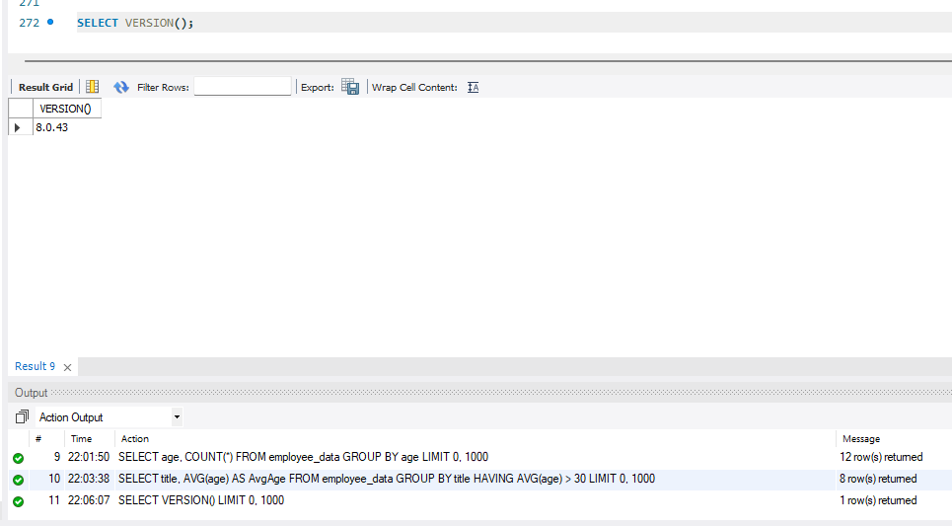

2. Use the SELECT command to evaluate 4 X 4 X 4 and name the column Cube of 4.
SELECT (4*4*4) AS `Cube of 4`;
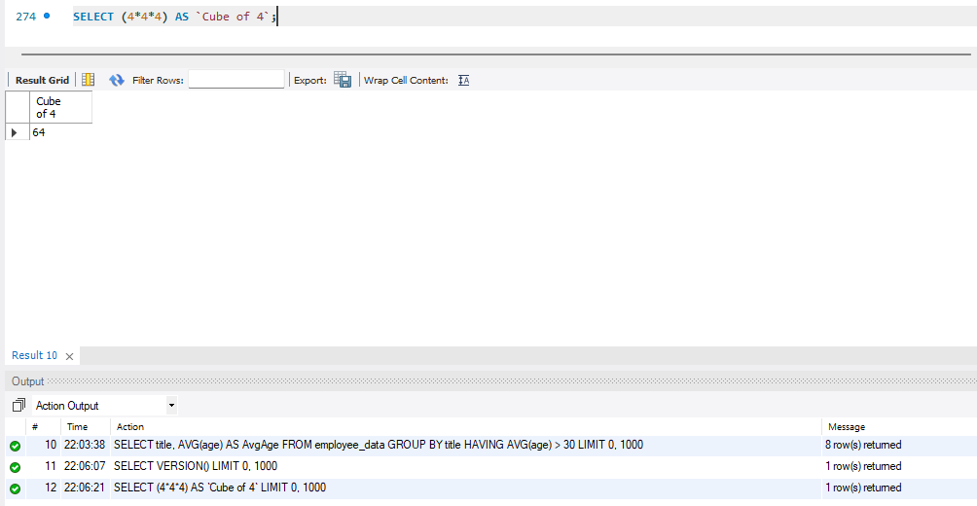
3. Display your name with SELECT.
SELECT 'Alessandra Rivano'; 